EAST AFRICA SAFARI & BEACH HOLIDAYS

Day 1: NAIROBI-MAASAI MARA
Upon arrival you will be welcomed and transferred to Wilson Airport

The flight will depart at 1000hrs and arrive at 1100hrs at Serena Aistrip
In Maasai Mara you will meet your driver guide ready for you.

Camp/Lodge/Resort: Mara Serena Safari Lodge

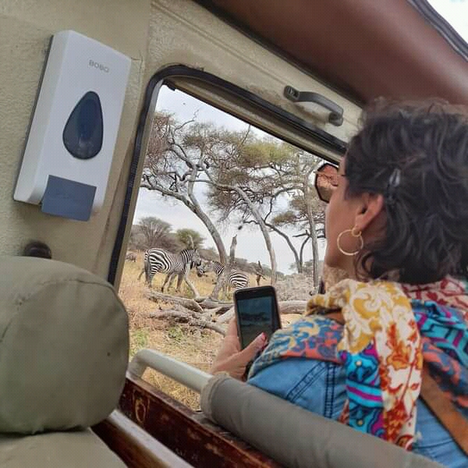
Day 2: MAASAI MARA NATIONAL RESERVE

After breakfast leave for a morning game viewing till lunch time. Spend the day in Maasai Mara, Kenya's most popular game reserve where you will have the best opportunity of spotting the Big Five - lion, leopard, buffalo, rhino and elephant. Evening game viewing starts at 4pm.
Camp/Lodge/Resort: Mara Serena Safari Lodge

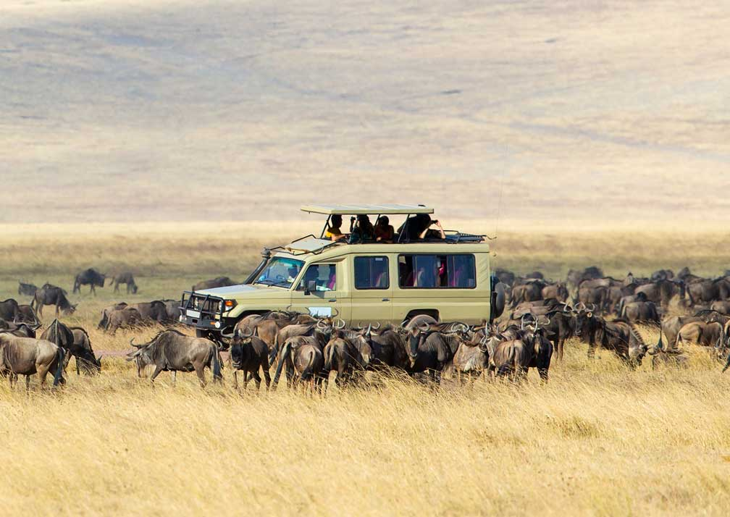
Day 3: MAASAI MARA NATIONAL RESERVE
After breakfast leave for a morning game viewing till lunch time. Spend the day in Maasai Mara, Kenya's most popular game reserve where you will have the best opportunity of spotting the Big Five - lion, leopard, buffalo, rhino and elephant. Evening game viewing starts at 4pm.

Camp/Lodge/Resort: Mara Serena Safari Lodge

Day 4: MAASAI MARA NATIONAL RESERVE

After breakfast, check out of the camp and head to the airstrip. The flight to Nairobi departs at 1100 hrs. and arrive at 1220hrs. Depending on your international flight you may have time to visit the famous Giraffe Centre to feed the Giraffes with pellets as to learn more about them and also have time to but souvenirs. After, you will head to the airport to catch up with your international flight to Kampala.

Upon arrival James will do a debriefing and that will mark the end of the safari.
Day 5: ARRIVAL AND TRANSFER TO YOUR HOTRL FOR DINNER AND OVERNIGHT
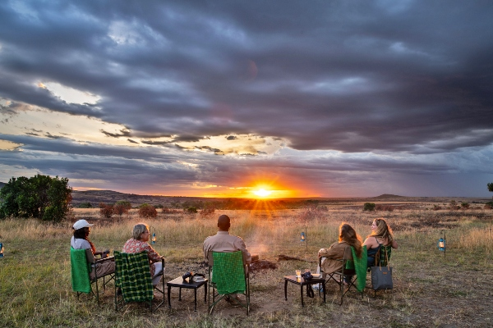
Day 6: TRANSFER TO KIBAALE FOREST NATIONAL PARK
This day marks the beginning of your safari. It begins with meeting your driver guide who shall be your company throughout the entire trip. He shall then transfer you to Kibaale forest National Park. The park is in Western Uganda and approximately 350km from Kampala giving us an average of a 5-6 hours’ drive to the park trans versing through lush green hills, and perhaps the best scenic spots. The park is home to over 13 primate species, over 300 bird species and over 1000 individuals of Chimpanzees.
We shall have lunch in Fortportal, visit Amabere Ga Nyina Mwiru, Toro palace and then proceed with our journey to the park. Upon arrival we shall head to our accommodations for refreshment, relaxation, dinner and overnight stay.
MEAL PLAN: HALF BOARD
DESTINATION: KIBAALE FOREST NATIONAL PARK
ACCOMMODATION OPTIONS: KYANINGA LODGE/ PRIMATE LODGE/ CHIMPUNDU LODGE

Day 7: CHIMPANZEE TREKKING AND BIGODI SWAMP WALK
Wake up early, have breakfast and head out to the Park’s headquarters for briefing about the chimpanzee trekking activity. Chimpanzee trekking is one of the most sought for activities by tourists visiting Uganda. Uganda is home to over 4500 chimpanzees and Kibaale forest alone is home to over 1500, meaning you stand over a 70% chance of spotting our closest relatives. Having 98% of Human DNA, an encounter with the chimps will surely live you in awe of The Pearl of Africa. The trekking time usually depends on where the chimps are, after the trekking, we shall head to our lodges, have lunch, refresh and then prepare to head out to Bigodi wetland.
Bigodi wetland, nicknamed ‘the home of the great blue Turaco’ is an area filled with rich bio-diversity and a guided nature walk through this 4.5km long wildlife corridor is definitely worth it. You shall spot among several others birds hornbills, kingfishers, parrots and cranes, primates like the black and white Colobus monkey, vervet monkeys, red tailed monkeys and on a lucky day the Sitatunga antelope. You shall also have some time to interact with the community members and perhaps have a glimpse on the beautiful art and craft materials that they make. When done we shall head back to our accommodation, refresh, relax, have dinner and rest for the night.
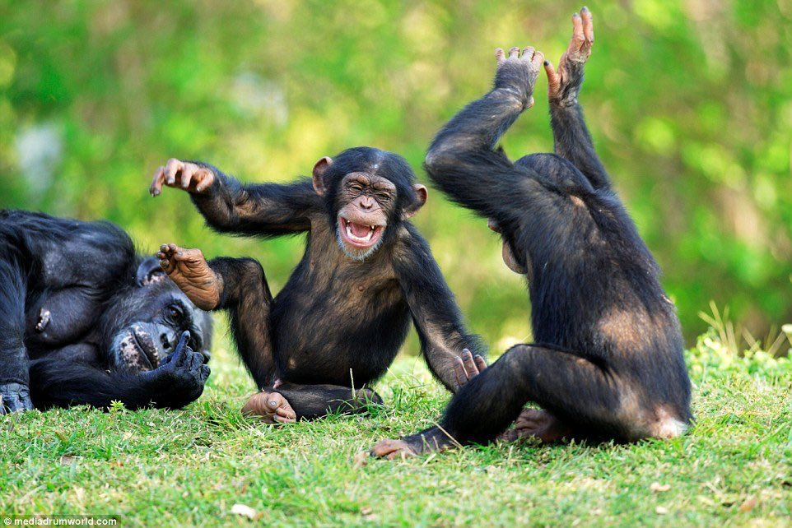

MEAL PLAN: FULL BOARD
ACCOMMODATION OPTIONS: KYANINGA LODGE/ PRIMATE LODGE/ CHIMPUNDU LODGE

Day 8: TRANSFER TO QUEEN ELIZABETH NATIONAL PARK
This is the third day of our trip and it shall be for transfer to Queen Elizabeth National Park. The drive is about 2 hours, Trans versing through lush green terraced hills and beautiful landscapes that will leave you in awe of the Pearl of Africa. We may do some crater lakes exploration, where we shall visit one of the crater lakes found in south western Uganda, have time for Photography and an in-depth explanation of any history attached to the lakes. We shall then continue with our journey to the Park arriving, in time for lunch and refreshment. After lunch, we may head out to the Basonghola community for an immersive cultural experience where you get to dive into the ways of life of the Basonghola through, Music, art, dance, drama and Culinary art after which, we shall head to our accommodations, for dinner, refreshment and overnight stay.
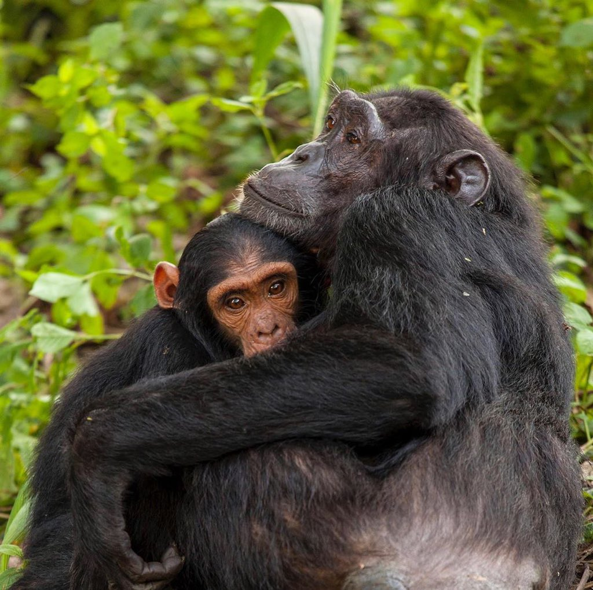

MEAL PLAN: FULL BOARD
DESTINATION: QUEEN ELIZABETH NATIONAL PARK
ACCOMMODATION OPTIONS: ELEPHANT PLAINS LODGE/ MWEYA SAFARI LODGE
Day 9: GAME DRIVE AND KAZINGA CHANNEL BOAT CRUISE
This is the Fourth day of our trip and it shall be for exploring Uganda’s Medley of Wonders. The day shall begin with breakfast at our accommodation and then transfer to Kasenyi plains for a fun filled and memorable game drive experience, in Uganda’s most visited game park. Expect to see among several other animals, lions, buffaloes, giraffes, waterbucks and several bird species as the park is blessed with over 600 different bird species. After the Game drive, we head to our lodges for refreshment, lunch and a little relaxation before we embark on our sunset Boat cruise along Kazinga Channel. This channel is a 32km long natural waterway that joins Uganda’s lakes, George and Edward and has the highest concentration of Hippopotamus in Uganda. Have a cruise on this natural wonder, with ample time for photography after which we shall head to our accommodation for, refreshment, dinner and overnight stay.
MEAL PLAN: FULL BOARD
ACCOMMODATION OPTIONS: ELEPHANT PLAINS LODGE/ MWEYA SAFARI LODGE
DAY 10: TRANSFER TO ZANZIBAR
This is the last day of your safari, and it shall be for transfer back to Kampala. Have breakfast at the hotel then embark on your journey to Kampala/ Entebbe for your flight to Zanzibar. Arrive in Zanzibar and transfer to the beach hotel.

Day 11: SPICE FARM & STONE TOWN
Upon arrival you will meet our guide in Zanzibar airport then transfer to stone town for seeing the city have most structure which was built-in 19 Century when Zanzibar was thriving trading community the wonderful labyrinthine streets of stone town then you will see Anglican Church, slave chambers, Darajani fish market, passing on narrow routs, House of wonder this place is the first of Zanzibar to have electricity and current water and the first in East Africa to have electric elevator. Then you will have lunch break (Own payment) before you continue to spice farm you will see variety of spices such as, Cloves, Nutmeg, Cinnamon, Ginger, Vanilla, turmeric, Black paper, Chill etc. from planting to harvesting and even processing as most of them are used for domestic purpose in cooking, medicine and some for perfumes making. You will also taste exotic fruits like Mango, Pineapple, Orange and Banana. Jackfruit etc. these are seasonal fruits available in the Island. After that you will be transferred to hotel for dinner and overnight.
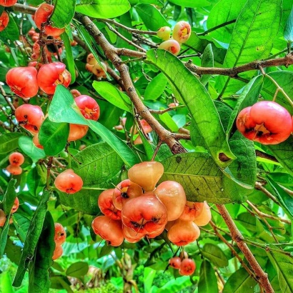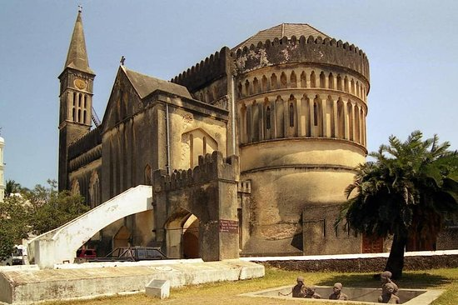

Day 12: FULL DAY AT LEISURE

This day is free for you to relax in the hotel for your own activities, you can decide to swim, play or just relax at the beach for leisure.
Day 13: SWIMMING WITH TURTLE
After breakfast at the hotel your will be transferred to around Nungwi area for swimming with Turle excursion. This is a private aquarium that keeps giant and unique sea Turtle in Zanzibar Island. Then you back to the hotel for dinner and overnight.
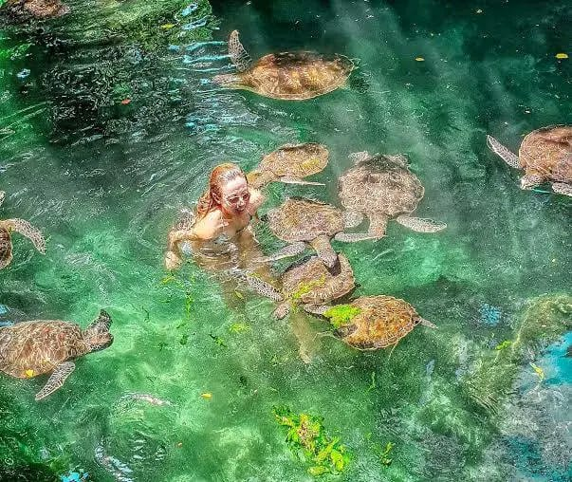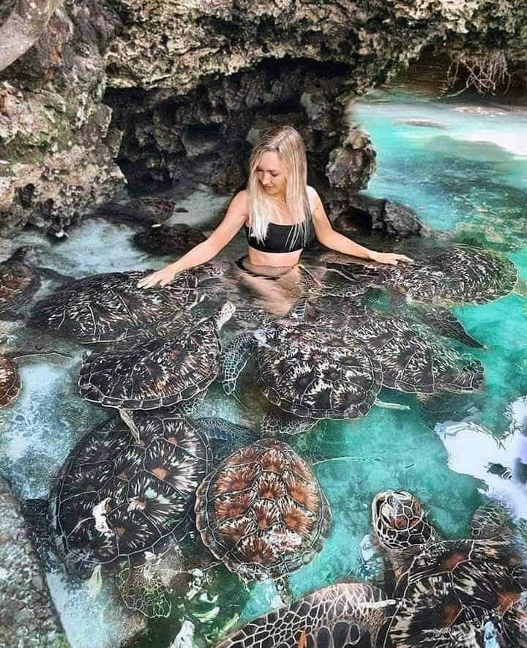
Day 14: DEPARTURE
Enjoy your last day at our beautiful white sand beach of Zanzibar while waiting the pickup depend on your flight schedule.
Package price:
Midrange | single | Per person Sharing | Budget | Single | Per person Sharing
 | 4861 | 4228 |  | 4265 | 3580

The package includes:
- Safari in Uganda and Kenya
- Zanzibar beach holidays
- Full board accommodation in Uganda and Kenya
- Half Board accommodation in Zanzibar
- Excursions through out trip as specified in the program
- Transport in a pop-up roof land cruiser
- Return ticket from Nairobi to Maasai Mara
- Airport transfers in Nairobi to Jomo Kenyatta International Airport
- All park entry fees
- Services of a professional, experienced English-speaking driver/guide
- Bottled drinking water
- Government taxes &local levies
- All game drives as per the itinerary

Package excludes
- All items of personal nature
- All items of a personal nature
- International flights
- Last day lunch in Nairobi
- Visa fee
- Laundry
- Visit to Maasai Village in Maasai Mara @USD 20 per person
- Tips and gratuities

